Day 2: Linux / WSL Lab Report

Name: | Muhammad Kaleem Faryad
Lab Title: | Shell Scripting & Automation
Date: | 03/05/2026

Objective
- Learn Bash scripting fundamentals.
- Automate repetitive tasks using scripts.
- Handle command-line arguments and errors.
- Implement conditionals, loops, and functions.
- Develop robust and reusable shell scripts.

Exercise 1: File Organizer Script
Objective
To organize files in a directory into subfolders based on their file extensions.

Script: organizer.sh
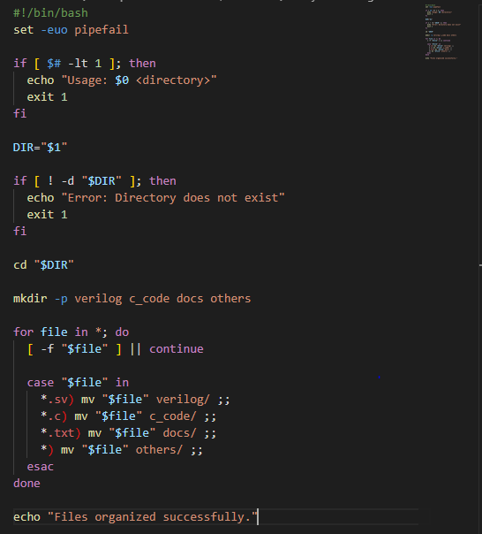

Explanation
- Accepts a directory path as a command-line argument.
- Validates that the directory exists before proceeding.
- Uses a case statement to match file extensions and sort files.
- Automates organization into verilog/, c_code/, docs/, and others/.

Output
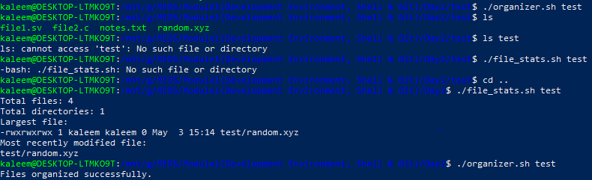

Exercise 2: File Statistics Script
Objective
To analyze a directory and display comprehensive file statistics.

Script: file_stats.sh
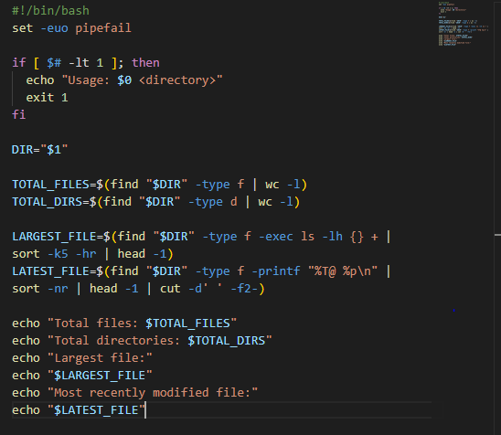

Explanation
- find -type f / -type d counts files and directories separately.
- wc -l counts the number of output lines from find.
- ls -lh with sort -k5 -hr identifies the largest file by size.
- -printf "%T@" outputs modification timestamps for sorting.

Output
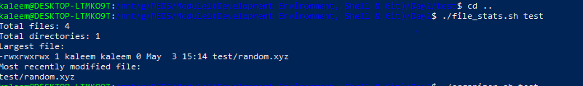

Exercise 3: Simulation Log Checker
Objective
To analyze simulation log files and summarize errors, warnings, and pass results.

Script: sim_checker.sh
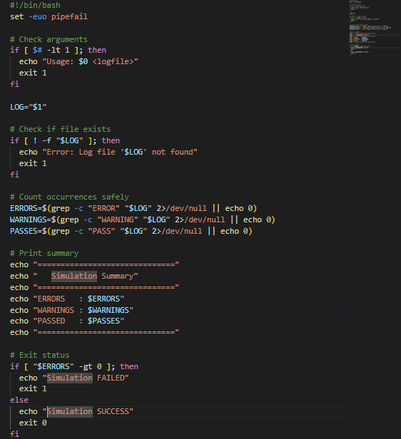

Explanation
- Validates log file existence before processing.
- grep -c counts matching lines for ERROR, WARNING, and PASS keywords.
- Displays a formatted summary table to the terminal.
- Returns a non-zero exit code if any errors are found — safe for CI pipelines.

Output
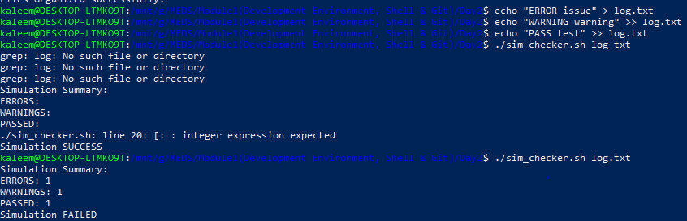

Exercise 4: Batch Rename Script
Objective
To rename multiple files in bulk using configurable prefix and suffix patterns.

Script: batch_rename.sh
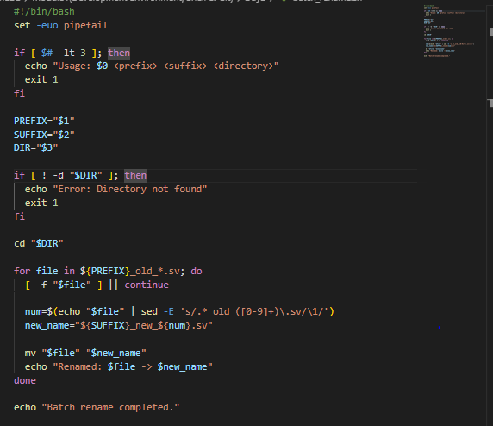

Explanation
- Accepts prefix, suffix, and directory as three positional arguments.
- Uses glob pattern matching to find only the targeted files.
- sed -E extracts the numeric part from each filename with a regex.
- Constructs the new name dynamically and renames using mv.

Output
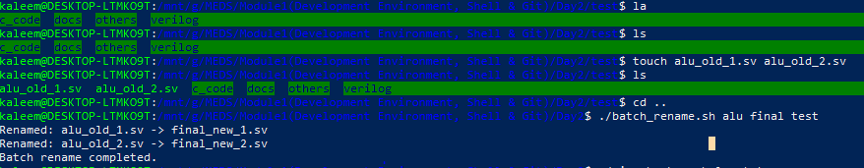

Challenges Faced
- Handling file paths that contain spaces or special characters.
- Passing the correct number and order of arguments to each script.
- Managing file existence errors gracefully without crashing the script.
- Debugging Bash syntax issues such as quoting and word splitting.

Learning Outcomes
- Understood the structure and execution flow of Bash scripts.
- Learned how to validate arguments and handle errors robustly.
- Implemented loops, conditionals, and case statements effectively.
- Gained hands-on experience with file manipulation commands.
- Improved debugging skills and error handling in shell environments.

Conclusion
This lab provided hands-on experience with shell scripting and automation. By developing multiple scripts, we learned how to efficiently manage files, process logs, and automate tasks in a Linux environment.
These skills are essential for system programming, DevOps, and software development workflows.

Linux / WSL Lab Report Day 2 — Muhammad Kaleem Faryad

